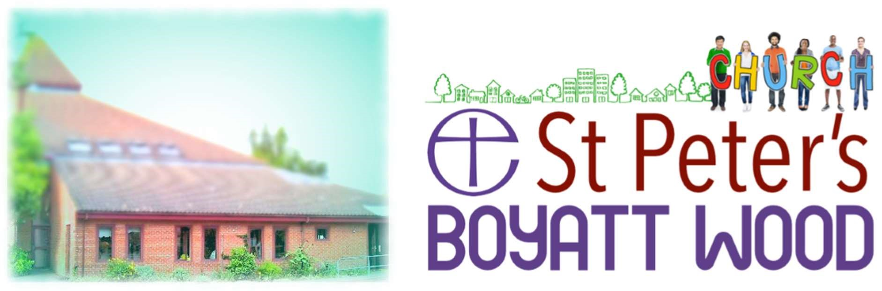

PART-TIME CHURCH
ADMINSTRATOR

We are looking for a friendly, confident and organised person with experience in administration. Excellent IT and communication skills and attention to detail are essential for this position.
Based in the Parish Office, duties include ensuring the smooth running of all aspects of Church administration in support of the Incumbent, visitors, ministers and church members.

15 hours per week
(Ideally: 5 mornings of 3 hours, 9.15am to 12.15)
£10.50/hour
Closing date for applications Monday 23rd March with interviews being held on Wednesday 1st April, 2020. For further details and an application form please contact – Yvonne Dawson at
churchwardenyvonne@parishofboyattwood.org.uk

